AWS CloudFormation – Infrastructure as Code (IaC)
🚀 What is AWS CloudFormation?
AWS CloudFormation is a service that allows you to define and provision AWS infrastructure using code. It helps in automating resource creation, managing configurations, and maintaining consistency across environments.

🔹 Why Use AWS CloudFormation?
✅ Automates Infrastructure Deployment – No need to manually create resources.
✅ Infrastructure as Code (IaC) – Define AWS resources in JSON/YAML templates.
✅ Consistent & Repeatable Deployments – Avoids manual errors.
✅ Easy Scaling & Updates – Modify infrastructure by updating templates.
✅ Rollback Feature – If deployment fails, CloudFormation rolls back changes automatically.

🔹 How AWS CloudFormation Works?
CloudFormation uses a template file to define resources and deploys them as a stack.
📌 Template File → 📌 CloudFormation Service → 📌 Stack with AWS Resources

🔹 AWS CloudFormation Components
- Templates – Written in JSON or YAML, they define AWS resources (EC2, RDS, S3, etc.).
2. Stacks – A collection of AWS resources created from a template.
3. Change Sets – Allows previewing changes before applying them.
4. Drift Detection – Identifies changes made outside CloudFormation.
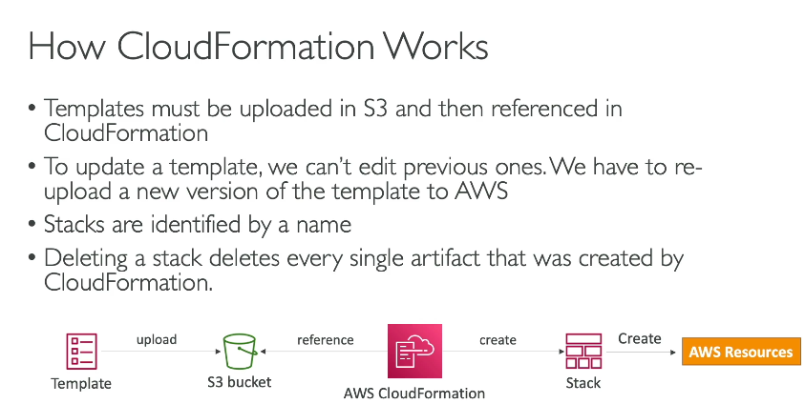

What is YAML?
YAML (Yet Another Markup Language or YAML Ain't Markup Language) is a human-readable data format often used for configuration files, data serialization, and automation scripts.
✅ Simple & easy to read (uses indentation instead of brackets)
✅ Supports hierarchical data (like JSON, but more readable)
✅ Commonly used in DevOps, Kubernetes, AWS CloudFormation, Ansible, Docker, etc.

🔹 Basic YAML Syntax Rules
📌 Indentation: Uses spaces (NOT tabs)
📌 Key-Value Pair: key: value
📌 Case-Sensitive
📌 Lists & Arrays: Use - (hyphen)
📌 Comments: Start with #

🚀 Infrastructure Overview:
We will define an infrastructure setup where:
✅ An EC2 instance (Ubuntu-based) is launched.
✅ A Security Group allows only HTTP (80) and SSH (22) traffic.
✅ An Elastic IP is attached to the EC2 instance.
✅ User Data script will install an Apache Web Server automatically.

📌 YAML Code (CloudFormation Template)
AWSTemplateFormatVersion: "2010-09-09"
Description: "CloudFormation template to launch an EC2 instance with a Security Group and Elastic IP"
Resources:
# Security Group
MySecurityGroup:
Type: AWS::EC2::SecurityGroup
Properties:
GroupDescription: "Allow SSH and HTTP traffic"
SecurityGroupIngress:
- IpProtocol: tcp
FromPort: 22
ToPort: 22
CidrIp: 0.0.0.0/0 # Allows SSH from anywhere (Not recommended for production)
- IpProtocol: tcp
FromPort: 80
ToPort: 80
CidrIp: 0.0.0.0/0 # Allows HTTP access from anywhere
VpcId: !Ref MyVPC # Reference to VPC (optional)

# EC2 Instance
MyEC2Instance:
Type: AWS::EC2::Instance
Properties:
InstanceType: t2.micro
ImageId: "ami-0abcdef1234567890" # Replace with latest AMI ID
KeyName: "my-key-pair" # Replace with your key pair
SecurityGroupIds:
- !Ref MySecurityGroup
Tags:
- Key: "Name"
Value: "MyWebServer"
UserData:
Fn::Base64: |
#!/bin/bash
apt update -y
apt install -y apache2
systemctl start apache2
systemctl enable apache2
echo "Hello from EC2 Instance" > /var/www/html/index.html

# Elastic IP
MyElasticIP:
Type: AWS::EC2::EIP
Properties:
InstanceId: !Ref MyEC2Instance

Outputs:
PublicIP:
Description: "Public IP of the EC2 instance"
Value: !Ref MyElasticIP

📖 Explanation of Each Section
1️ AWSTemplateFormatVersion & Description
AWSTemplateFormatVersion: "2010-09-09"
Description: "CloudFormation template to launch an EC2 instance with a Security Group and Elastic IP"
✅ AWSTemplateFormatVersion: Defines the template version.
✅ Description: Helps users understand the purpose of the template.

2️Security Group Configuration
MySecurityGroup:
Type: AWS::EC2::SecurityGroup
Properties:
GroupDescription: "Allow SSH and HTTP traffic"
SecurityGroupIngress:
- IpProtocol: tcp
FromPort: 22
ToPort: 22
CidrIp: 0.0.0.0/0 # Allows SSH from anywhere
- IpProtocol: tcp
FromPort: 80
ToPort: 80
CidrIp: 0.0.0.0/0 # Allows HTTP access from anywhere
✅ Defines a Security Group (Firewall rules)
✅ Allows SSH (port 22) and HTTP (port 80) access from any IP (0.0.0.0/0)
🚨 Security Note:
For production, replace 0.0.0.0/0 with a specific IP range to improve security.

3️EC2 Instance Creation
MyEC2Instance:
Type: AWS::EC2::Instance
Properties:
InstanceType: t2.micro
ImageId: "ami-0abcdef1234567890" # Replace with correct AMI ID
KeyName: "my-key-pair" # Replace with your key pair
SecurityGroupIds:
- !Ref MySecurityGroup
Tags:
- Key: "Name"
Value: "MyWebServer"
✅ Defines an EC2 instance
✅ Uses t2.micro (Free-tier eligible)
✅ Assigns a Security Group
✅ Tags the instance as "MyWebServer"

4️User Data Script
UserData:
Fn::Base64: |
#!/bin/bash
apt update -y
apt install -y apache2
systemctl start apache2
systemctl enable apache2
echo "Hello from EC2 Instance" > /var/www/html/index.html
✅ Runs at first boot to install Apache (HTTP server)
✅ Enables the web server to start automatically
✅ Creates an index.html file with a custom message

5️Elastic IP Allocation
MyElasticIP:
Type: AWS::EC2::EIP
Properties:
InstanceId: !Ref MyEC2Instance
✅ Allocates a Static Elastic IP to the instance
✅ Ensures that even if the instance stops & starts, the public IP remains the same

6️Output Public IP
Outputs:
PublicIP:
Description: "Public IP of the EC2 instance"
Value: !Ref MyElasticIP
✅ Displays the Elastic IP in the CloudFormation console output

🚀 How to Deploy this YAML Template in AWS CloudFormation?
1️Login to AWS Console
2️Go to CloudFormation → Create Stack → Upload the YAML file
3️Follow the wizard & launch the stack
4️Once deployed, get the EC2 Public IP from Outputs
5️Open a browser and visit http://<PublicIP>
6️You should see: "Hello from EC2 Instance"

AWS CloudFormation Resources
In AWS CloudFormation, resources are the building blocks of infrastructure. You define them in YAML or JSON format to automatically provision and manage AWS services.

🚀 Categories of AWS CloudFormation Resources
1️Compute Resources
- AWS::EC2::Instance → Creates EC2 instances
- AWS::EC2::SecurityGroup → Defines security groups (firewall rules)
- AWS::AutoScaling::AutoScalingGroup → Manages EC2 scaling
- AWS::Lambda::Function → Deploys AWS Lambda functions
2️Networking & Content Delivery
- AWS::VPC::VPC → Creates Virtual Private Cloud (VPC)
- AWS::EC2::Subnet → Defines subnets inside a VPC
- AWS::ElasticLoadBalancingV2::LoadBalancer → Creates Application/Network Load Balancer
- AWS::Route53::RecordSet → Configures DNS routing
3️Storage & Databases
- AWS::S3::Bucket → Creates Amazon S3 bucket
- AWS::DynamoDB::Table → Creates a DynamoDB table
- AWS::RDS::DBInstance → Creates an RDS database instance
- AWS::EBS::Volume → Creates an EBS storage volume
4 Security & IAM
- AWS::IAM::Role → Defines an IAM role
- AWS::IAM::Policy → Attaches IAM policies
- AWS::KMS::Key → Creates a KMS encryption key
5️Management & Monitoring
- AWS::CloudWatch::Alarm → Creates CloudWatch alarms
- AWS::CloudFormation::Stack → Nested stack management
6️Serverless & Application Integration
- AWS::SNS::Topic → Creates an SNS topic for notifications
- AWS::SQS::Queue → Creates an SQS queue
AWS CloudFormation Parameters
Parameters in CloudFormation allow you to customize templates by accepting user input at deployment time. This makes your infrastructure flexible and reusable.
🚀 Why Use Parameters?
1. Avoid hardcoding values (e.g., AMI ID, instance type)
2. Reuse templates for different environments (dev, prod)
3. Enable user input at runtime
4. Increase automation and flexibility
📌 Example: Parameters in CloudFormation
This example defines parameters for EC2 Instance Type and Key Pair to make the template configurable.
yaml
AWSTemplateFormatVersion: "2010-09-09"
Description: "EC2 instance with parameters"
Parameters:
InstanceType:
Type: String
Default: t2.micro
AllowedValues:
- t2.micro
- t2.small
- t2.medium
Description: "Choose an EC2 instance type"
KeyPair:
Type: AWS::EC2::KeyPair::KeyName
Description: "Enter the name of an existing EC2 KeyPair"
Resources:
MyEC2Instance:
Type: AWS::EC2::Instance
Properties:
InstanceType: !Ref InstanceType # Using parameter value
ImageId: "ami-0abcdef1234567890" # Replace with a valid AMI ID
KeyName: !Ref KeyPair
Tags:
- Key: "Name"
Value: "ParameterizedEC2Instance"
Outputs:
InstanceID:
Description: "The EC2 Instance ID"
Value: !Ref MyEC2Instance

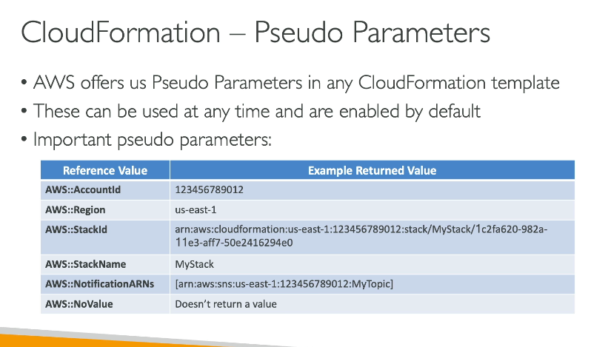

Difference Between Mappings & Parameters

Feature | Parameters | Mappings
Purpose | Allow user input at stack creation time | Store predefined key-value pairs (like a lookup table)
Flexibility | User-defined, customizable | Fixed values set in the template
Use Case | When values change per deployment (e.g., instance type, environment) | When values are static per region, OS, or environment
Example | Specifying an instance type during stack creation | Automatically selecting the AMI ID based on region
Parameters:
InstanceType:
Type: String
Default: t2.micro
Mappings:
RegionMap:
us-east-1:
AMI: "ami-12345678"
us-west-1:
AMI: "ami-87654321"
Resources:
MyEC2Instance:
Type: AWS::EC2::Instance
Properties:
InstanceType: !Ref InstanceType
ImageId: !FindInMap [RegionMap, !Ref "AWS::Region", AMI]

AWS CloudFormation Outputs
The Outputs section in CloudFormation lets you export values from your stack. You can use these outputs to:
- Display useful information after stack creation (e.g., public IP of an EC2 instance).
- Pass values between stacks when using cross-stack references.
- Retrieve values programmatically using AWS CLI or SDK.

📌 Basic Example: Outputting an EC2 Public IP
Resources:
MyEC2Instance:
Type: AWS::EC2::Instance
Properties:
InstanceType: t2.micro
ImageId: ami-12345678
Outputs:
InstancePublicIP:
Description: "Public IP of the EC2 instance"
Value: !GetAtt MyEC2Instance.PublicIp
👉 After stack creation, CloudFormation will display the EC2 Public IP in the console.

AWS CloudFormation Conditions
Conditions in CloudFormation allow you to dynamically control which resources are created based on input parameters or AWS environment settings.

📌 Why Use Conditions?
✅ Deploy different configurations based on environment (e.g., Dev vs. Prod).
✅ Create optional resources (e.g., provision an RDS only if needed).
✅ Optimize costs by avoiding unnecessary resources.

Full Example: Deploying an EC2 Instance Only in Production
Parameters:
EnvType:
Type: String
Default: Dev
AllowedValues:
- Dev
- Prod
Description: "Choose the environment (Dev or Prod)"
Conditions:
CreateProdResources: !Equals [!Ref EnvType, “Prod”]
Resources:
MyEC2Instance:
Type: AWS::EC2::Instance
Condition: CreateProdResources # ← EC2 is created only if EnvType = "Prod"
Properties:
InstanceType: t2.micro
ImageId: ami-12345678
Outputs:
EC2InstanceInfo:
Condition: CreateProdResources # ← Output is shown only if EC2 exists
Description: "EC2 Instance ID"
Value: !Ref MyEC2Instance
👉 If EnvType = Dev, the EC2 won't be created!
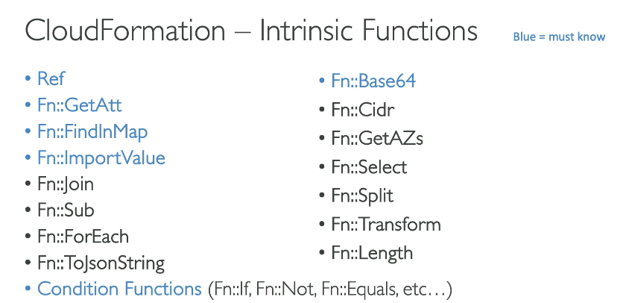

AWS CloudFormation Rollbacks
Rollback in AWS CloudFormation happens when a stack fails to create, update, or delete due to an error. CloudFormation automatically rolls back the changes to maintain the previous stable state.

📌 Types of Rollbacks in CloudFormation
- Stack Creation Rollback → If a resource fails during creation, CloudFormation deletes all created resources.
- Stack Update Rollback → If an update fails, CloudFormation reverts the stack to its previous state.
- Stack Deletion Rollback → If a resource fails to delete, rollback stops, and the stack remains in a DELETE_FAILED state.
- Manual Rollback → You can manually trigger a rollback if needed.

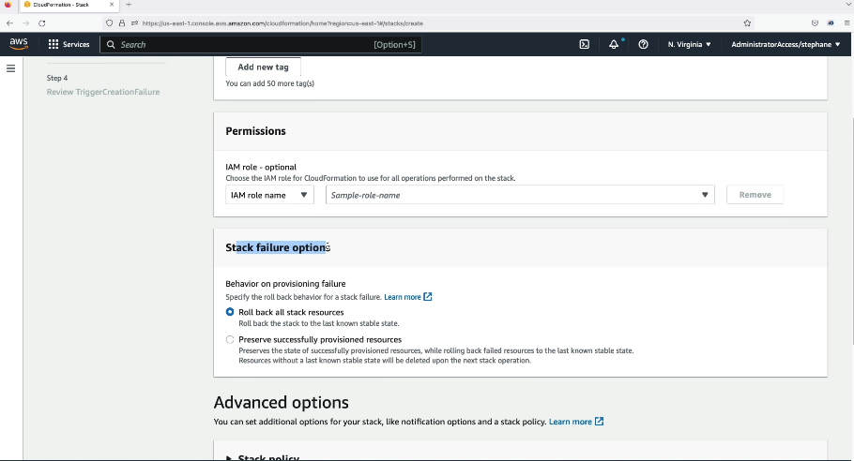
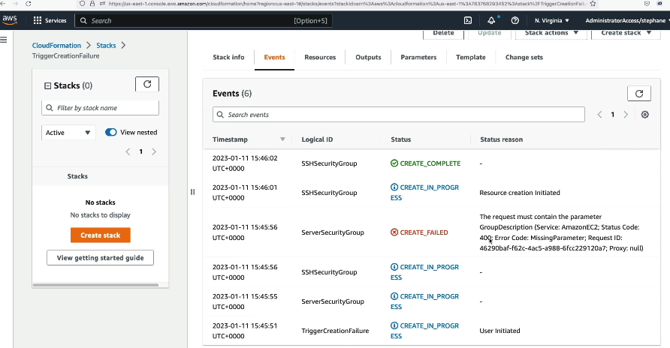

What is a Service Role?
A Service Role is an IAM role that an AWS service assumes to perform actions on your behalf.
✅ AWS services need permissions to interact with other AWS resources.
✅ Instead of using your own user credentials, AWS services use Service Roles.

📌 Example: Service Role for EC2 to Access S3
Let’s say you have an EC2 instance that needs to read/write data from S3.
🔹 Instead of using IAM user credentials, we assign a service role to EC2 with S3 permissions.
1. Create an IAM Role for EC2
- Attach an IAM policy to allow S3 access.
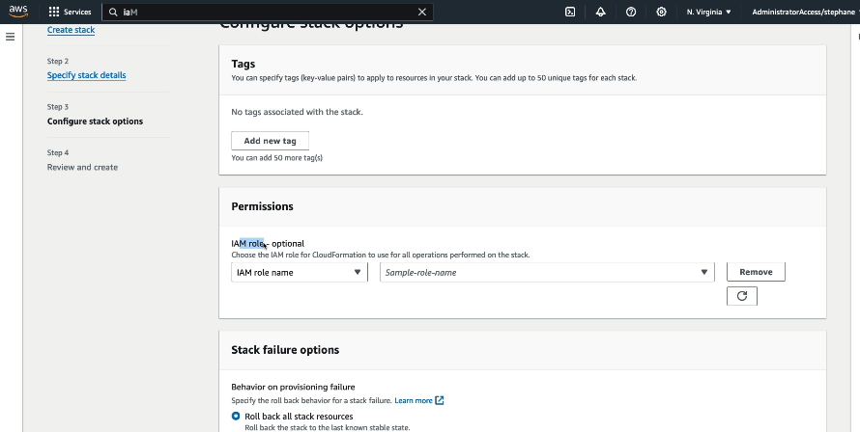
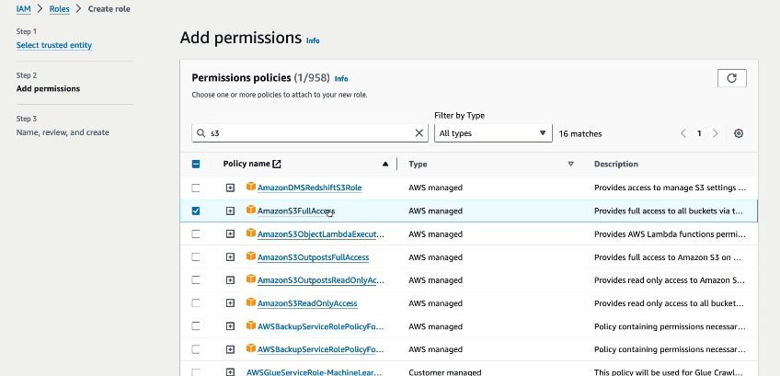
- Assign this role to the EC2 instance.

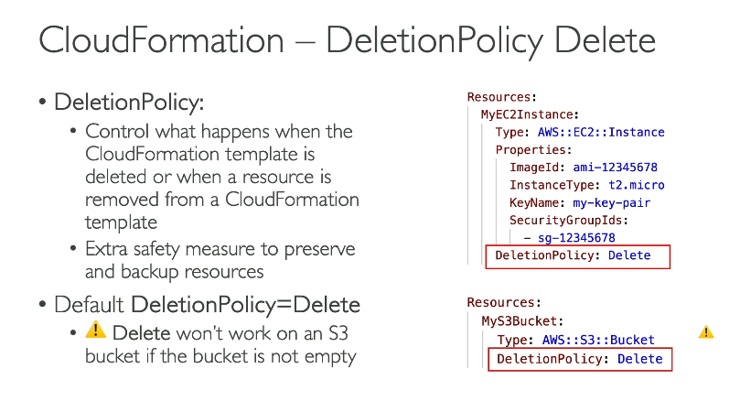
🔹 AWS CloudFormation Deletion Policy
📌 What is a Deletion Policy?
A Deletion Policy in AWS CloudFormation defines what happens to a resource when the stack is deleted. By default, CloudFormation deletes all resources when you delete a stack. However, you can override this behaviour using a Deletion Policy.

🛠️ Available Deletion Policy Options
Deletion Policy | Behaviour
Delete (Default) | The resource is permanently deleted when the stack is deleted.
Retain | The resource is not deleted and remains in your AWS account.
Snapshot | A snapshot (backup) of the resource is created before deletion. Only applicable to databases, EBS volumes, etc.

📌 When to Use Each Deletion Policy?
1️Delete (Default Behaviour)
- If you don’t specify a deletion policy, AWS deletes the resource when the stack is deleted.
- Use Case: Temporary resources like EC2 instances, Auto Scaling groups, or Lambda functions.
Example: Default Deletion (Resource Gets Deleted)
Resources:
MyS3Bucket:
Type: AWS::S3::Bucket
🔹 Since no DeletionPolicy is defined, the S3 bucket gets deleted when the stack is deleted.

2️Retain (Preserve the Resource)
- The resource remains in AWS even after deleting the stack.
- Use Case: When you don’t want to lose critical data like S3 Buckets, RDS Databases, or EBS volumes.
Example: Retaining an S3 Bucket
Resources:
MyS3Bucket:
Type: AWS::S3::Bucket
DeletionPolicy: Retain
🔹 Even if the CloudFormation stack is deleted, the S3 bucket remains in AWS.

3️Snapshot (Backup Before Deletion)
- AWS creates a snapshot (backup) of the resource before deleting it.
- Use Case: Used for databases (RDS, DynamoDB), EBS volumes, or any resource where you might need a backup before deletion.
Example: Taking a Snapshot of an RDS Database
Resources:
MyDatabase:
Type: AWS::RDS::DBInstance
DeletionPolicy: Snapshot
🔹 When the stack is deleted, a snapshot of the RDS database is created before it is removed.

📌 Key Takeaways
✔ Delete → Resource is removed (default behavior).
✔ Retain → Resource stays in AWS even after stack deletion.
✔ Snapshot → Backup is taken before deletion (for RDS, EBS, etc.).
Would you like an example related to your Chat App infrastructure (e.g., keeping your database safe)? 🚀

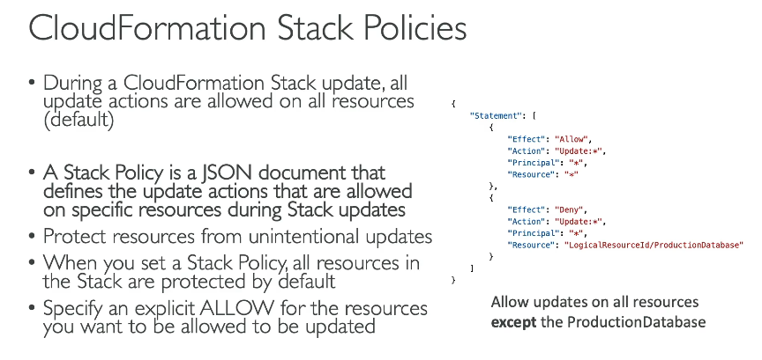
What is a Custom Resource?
AWS Custom Resources in CloudFormation allow you to execute custom logic by calling AWS Lambda functions or external APIs during stack creation, updates, or deletions.
✅ Used when CloudFormation does not support a specific AWS service or operation.
✅ Can automate external tasks, such as provisioning third-party services, setting up external configurations, or running scripts.

📌 How Custom Resources Work
1️CloudFormation creates the stack
2 It triggers a Lambda function (or external API) to perform a custom action
3️Lambda sends a response back to CloudFormation
4 CloudFormation proceeds with stack creation/update/deletion

1 CloudFormation creates an EC2 instance
2 he Lambda function is triggered to allocate and assign an Elastic IP
3 Lambda responds back to CloudFormation, completing the process

What are Dynamic References?
Dynamic References allow secure retrieval of sensitive values stored in AWS Systems Manager Parameter Store or AWS Secrets Manager at deployment time in AWS CloudFormation.
✅ Avoid hardcoding sensitive data like passwords, API keys, or database credentials
✅ Retrieve values dynamically without storing them in templates
✅ Improve security by managing secrets in AWS services

📌 Supported Services
Dynamic references can fetch values from:
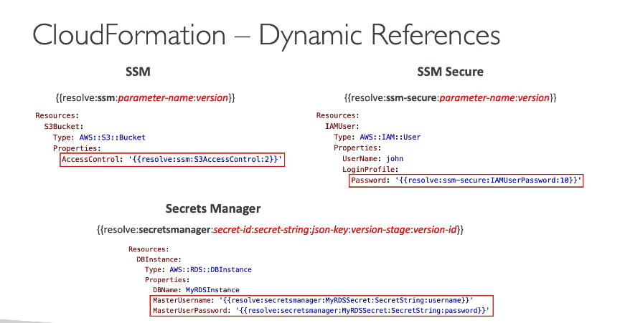
1. AWS Systems Manager Parameter Store (ssm or ssm-secure)
2 .AWS Secrets Manager (secretsmanager)

User Data in EC2: Automating Instance Initialization
🔹 What is User Data?
- User Data is a script that runs only once when an EC2 instance launches.
- Used for initial configuration, like installing software, setting up files, or running commands.
- Supports Bash scripts (Linux) or PowerShell scripts (Windows).
Example: CloudFormation Template with User Data
You can also define User Data in a CloudFormation template:
AWSTemplateFormatVersion: "2010-09-09"
Resources:
MyEC2Instance:
Type: AWS::EC2::Instance
Properties:
InstanceType: t2.micro
ImageId: ami-xxxxxxxxxxxx
UserData: !Base64 |
#!/bin/bash
yum update -y
yum install -y httpd
systemctl start httpd
systemctl enable httpd
✔ UserData must be Base64-encoded
✔ AWS CloudFormation handles Base64 automatically using !Base64
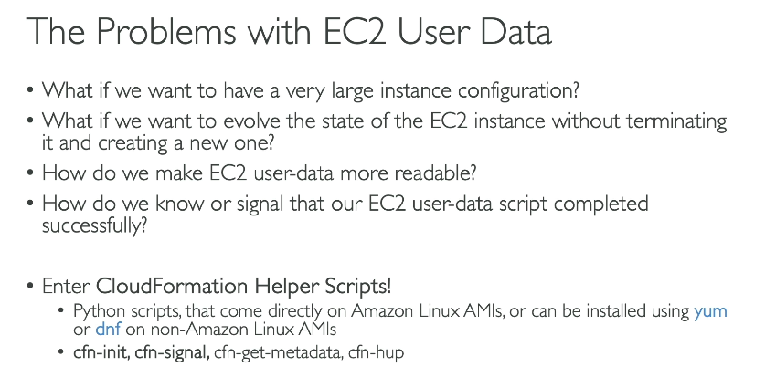

What is cfn-init?
- cfn-init is a CloudFormation helper script that automates instance configuration.
- It reads metadata from CloudFormation and sets up software, files, services, and more.
- More powerful than User Data because it allows step-by-step configuration & error handling.
📌 Key Features:
✔ Install software (Apache, MySQL, Docker, etc.)
✔ Configure files
✔ Manage system services
✔ Run commands
Example: Use cfn-init to Install Apache on EC2
1️Define Metadata in CloudFormation
AWSTemplateFormatVersion: "2010-09-09"
Resources:
MyEC2Instance:
Type: AWS::EC2::Instance
Metadata:
AWS::CloudFormation::Init:
configSets:
default:
- install_apache
install_apache:
packages:
yum:
httpd: []
services:
sysvinit:
httpd:
enabled: true
ensureRunning: true
Properties:
ImageId: ami-xxxxxxxxxxxx
InstanceType: t2.micro
KeyName: MyKeyPair
UserData:
Fn::Base64: |
#!/bin/bash
/opt/aws/bin/cfn-init -v --stack MyStack --resource MyEC2Instance --region us-east-1

What is cfn-signal?
cfn-signal is a CloudFormation helper script that notifies CloudFormation when an EC2 instance setup is complete.
It is used along with WaitCondition to pause CloudFormation until the instance is fully configured.
📌 Why use cfn-signal?
✔ Ensures instance setup is complete before proceeding
✔ Helps avoid application errors due to incomplete setup
✔ Useful in Auto Scaling Groups, Load Balancers, and multi-instance deployments
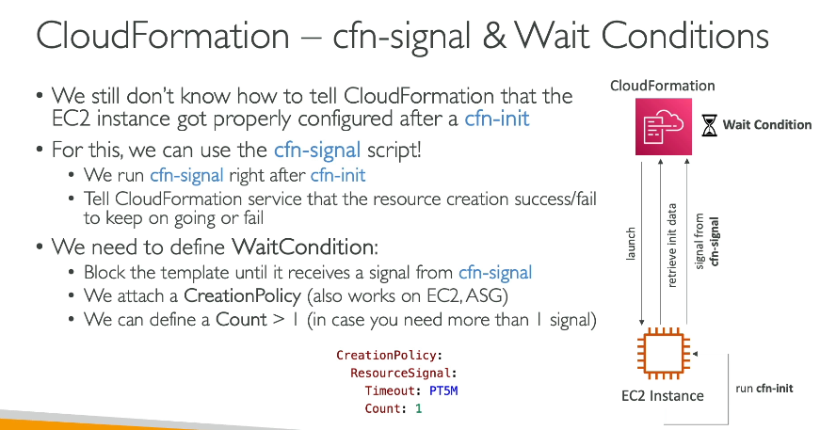

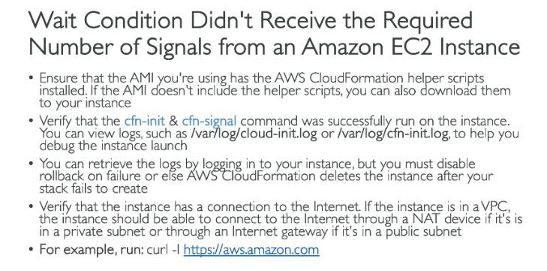

What is a Nested Stack?
A Nested Stack is a CloudFormation stack within another stack. It helps break down large templates into smaller, reusable, and more manageable stacks.
📌 Why use Nested Stacks?
✔ Modular Design – Separate infrastructure components
✔ Reusability – Use the same template in multiple environments
✔ Better Organization – Keep main stack clean and readable
✔ Easier Maintenance – Modify specific parts without changing everything

🛠️ How Nested Stacks Work
A parent stack references a child stack using the AWS::CloudFormation::Stack resource.
- The parent stack passes parameters to the child stack.
- The child stack returns outputs that the parent stack can use.
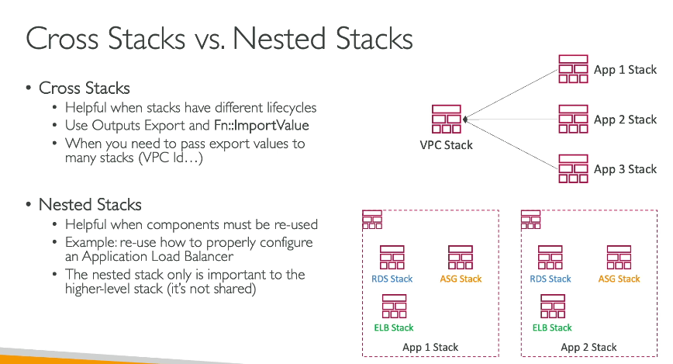

What is DependsOn?
The DependsOn attribute in AWS CloudFormation ensures that one resource is created before another.
📌 Why use DependsOn?
✔ Control Resource Creation Order – Ensures dependencies are met
✔ Avoid Errors – Some resources need others before they can be created
✔ Explicit Dependency Management – Even when CloudFormation implicitly handles order, you can force dependencies

📌 Example: Deploying a ChatApp on EC2 with a Security Group and IAM Role
Scenario:
- You need to launch an EC2 instance
- The Security Group must be created before the EC2 instance
- The IAM Role must also exist before the EC2 instance

What is StackSet?
AWS CloudFormation StackSet allows you to create, update, and delete CloudFormation stacks across multiple AWS accounts and regions simultaneously.
📌 Key Use Cases:
✔ Deploy infrastructure across multiple AWS accounts & regions
✔ Enforce security policies and compliance
✔ Manage infrastructure at scale
